
Car Price Prediction Project

Submitted by:
Gondesi Siva Ram Santosh Reddy
ACKNOWLEDGMENT

I wold like to add some refresences which helped me to solve this project

For data analysis part i have used pandas, you can find the link below

https://pandas.pydata.org/

And for visualization i used matplotlib, seaborn,sweetviz for generating report and yellowbrick for vistualizing the metrics of the data

https://matplotlib.org/

https://seaborn.pydata.org

For visualizing the residual plots and other error plots i used yellobrick
https://www.yellowbrick.co

for some statistical analysisi i have used scipy
https://www.scipy.org

And at last for numerical calculation i used Numpy and Scipy
https://numpy.org

INTRODUCTION

- Business Problem Framing

With the covid 19 impact in the market, we have seen lot of changes in the car market. Now some cars are in
demand hence making them costly and some are not in demand hence cheaper. One of our clients works with
small traders, who sell used cars. With the change in market due to covid 19 impact, our client is facing problems
with their previous car price valuation machine learning models. So, they are looking for new machine learning
models from new data. We have to make car price valuation model. This project contains two phase-
Data Collection Phase –

You have to scrape at least 5000 used cars data. You can scrape more data as well, it’s up to you.
More the data better the model
In this section You need to scrape the data of used cars from websites (Olx, cardekho, Cars24 etc.)
You need web scraping for this. You have to fetch data for different locations. The number of
columns for data doesn’t have limit, it’s up to you and your creativity. Generally, these columns are Brand, model,
variant, manufacturing year, driven kilometers, fuel, number of owners, location and at last target variable Price of
the car. This data is to give you a hint about important variables in used car model. You can make changes to it,
you can add or you can remove some columns, it completely depends on the website from which you are fetching
the data.
Try to include all types of cars in your data for example- SUV, Sedans, Coupe, minivan, Hatchback. Note – The
data which you are collecting is important to us. Kindly don’t share it on any public
platforms.

Model Building Phase-
After collecting the data, you need to build a machine learning model. Before model building do all data pre-
processing steps. Try different models with different hyper parameters and select the best model.

- Conceptual Background of the Domain Problem
With the covid 19 impact in the market, we have seen lot of changes in the car market. Now some cars are in demand hence making them costly and some are not in demand hence cheaper. One of our clients works withsmall traders, who sell used cars. With the change in market due to covid 19 impact, our client is facing problemswith their previous car price valuation machine learning models. So, they are looking for new machine learning models from new data. We have to make car price valuation model. This project contains two phase-
Data Collection Phase –
Model Building Phase -
- Review of Literature
With the covid 19 impact in the market, we have seen lot of changes in the car market. Now some cars are in demand hence making them costly and some are not in demand hence cheaper. One of our clients works withsmall traders, who sell used cars. With the change in market due to covid 19 impact, our client is facing problemswith their previous car price valuation machine learning models. So, they are looking for new machine learning models from new data. We have to make car price valuation model. This project contains two phase-
Data Collection Phase –
Model Building Phase -

- Motivation for the Problem Undertaken
As a datascient we have tools and kowledge to handle the such data and draw insights from the data to easily visualize and represent the the way we can both visually and statistically so we have to use that data to develop a model so that it will predict the prices and also shows which features are important

Analytical Problem Framing

- Mathematical/ Analytical Modeling of the Problem
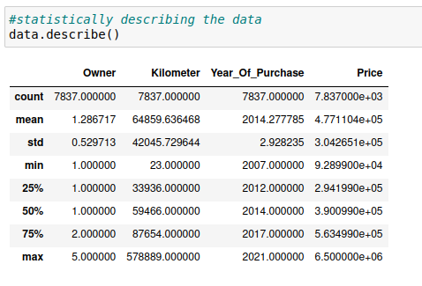

We used many statistical and mathematical function used in the project in python we have a library called pandas where we have some statistical functions like .describe() where we are checking some statistical informations like mean, median, standard deviation and percentils
And there are so many other functions like z scores and IQR which are used in outliers detection and treatment and cheking the correlation and covarience of the data, by the analysis of the data set we found that there are many outliers in the data only some them are handled and also data is skewed which are handled using power-transform method

Data Sources and their formats

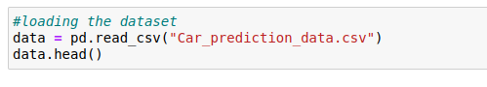

there is not data provided we have to make our own data i ahve used Beautiful soup and requests to scrape e commese data and also i have used many pandas topic to make it to a dataframe nad store it in csv file and the shape of dataset is 28000 rows and 4 columns

Data Preprocessing Done
There is mush data preprocessing theat should be done we have data that is mixture of both categorical and numerical data and also we have to encode the data so that we can fee it to model as machine learning model needs simple data to learn, as we are predicting the prices of cars we have to use linear regression in order to predict the prices of the cars
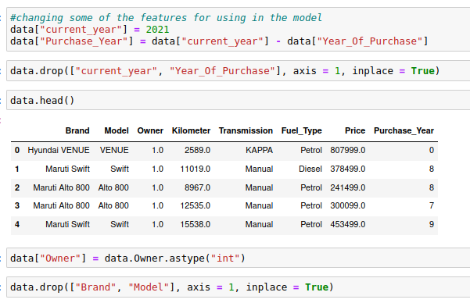

- Data Inputs- Logic- Output Relationships
if we observe the datsets carefully we have 8 dimensions and we have to one target variable called Prices we need to predict with the target so we need to do some preprocessing and then we need to create model

- State the set of assumptions (if any) related to the problem under consideration
We have to biuld a machine learning model based on the the input data given to us and we have to predict the prices of the cars and also the important features that are useful to predict the prices

- Hardware and Software Requirements and Tools Used
There is no specific details about hardware specifications, but when we come to sofware specifications we should have python installed along with anaconda navigator where we have to install jupyter notebook with all libraries like Numpy, scipy and matplotlib and other some libraries to be installed, and for moddel creation we have to install scikit learn, if you have a plaptop of low configuration then we have Google colab which is a great alternative choice, but wuth a great connetivity.

Model/s Development and Evaluation
In model building and evaluation we have to first install
scikit-learn library aong with the python

Identification of possible problem-solving approaches (methods)
Regarding this project we have used many methods for both statisticaly nad mathematiclly and for analysis we have used many mehods like
.head() for displaying the first 5 columns of the dataset
.describe() displays statistical details of the dataset
.isnull() displays the nullvalues in the dataset
.nunique() to display unique data of all columns
.corr() for checking the correlation between variables
.cov() for creating covarience matrix for PCA method
.drop() to drop unnecessay columns in the dataset
.skew() to check the skewness of data
And we have used many methods from scikit learn like
We are using many scaling methods like Standardscalar() to standardize the data, Robustscalar to adjust the outliers and the power_transform for adjusting the skewness and to scale the data that is used in model building, as all the machine learning models only require normalized data to create models

- Testing of Identified Approaches (Algorithms)
Now we are ready with the dataset we have to predict the prices of cars we have to use regression models for model building
By the cross validation we can see the models score

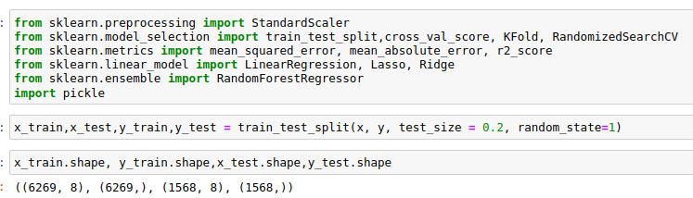
i am going to predict using normal model prediction
and find the score difference we get the best model with
low difference

- Run and Evaluate selected models
we are going to predict using normal algorithms and we will see hows it going to work and whats the accuracy be

Now tlets check the metrics of the model we have

In this we can see we have accuracy score an other metrics of Linear SVC and Multinomial NB

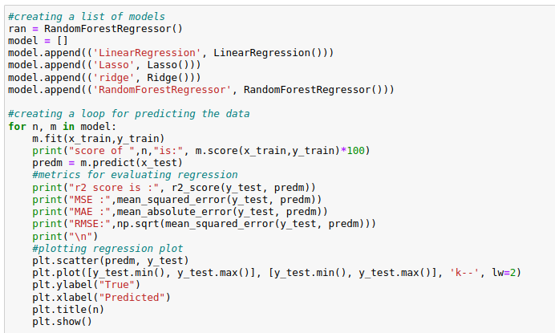

we have all scores and metrics of the models and when
compared with the cross-val-scores we got random forest
as the best model , so i am gona pick rMultinomialNB and
continue with hyperparameter tuning and savong the
model
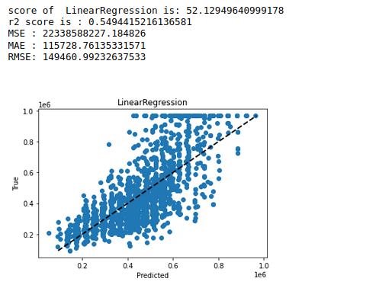

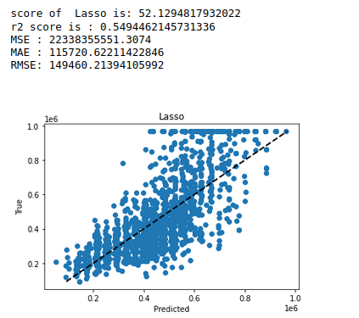

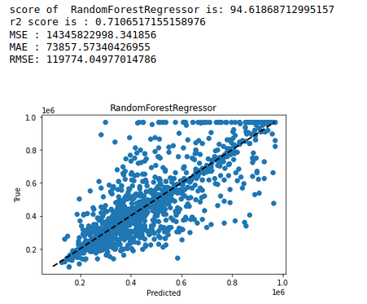

- Key Metrics for success in solving
problem under consideration

when we talk about the key metrics like r2 score ,mean square erro and mean absolute error, and also there are another metrics like cross val score where we use validation to check the accuracy of the model

Hyperparametertuning is the next conept we used in this model as it will improve the model accuracy and here iam using Random forest regressor for fine tuning the model to see weather accuracy improved or not

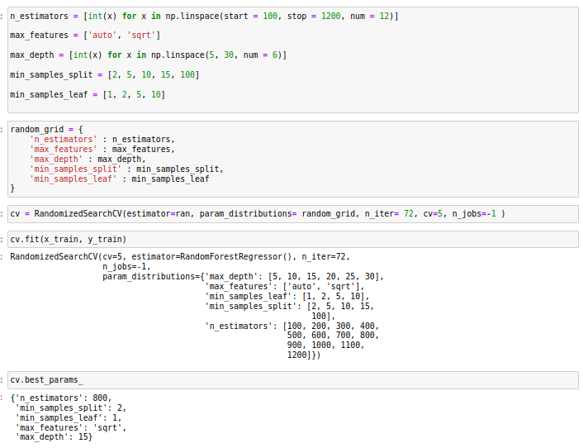

We can use Hyperparameter tuning to fine tume any model

- Visualizations

visualizing is the most importinant thing in the daascience where we wanto torespresent the data into visual form so that clients can understand that easily and and also we can show the relation of each variable and aslo mainly with the target variable, in this project i have used many visualization where iused to represent hte data and also the relation with the target variable
we can used different types of visualization for different situations

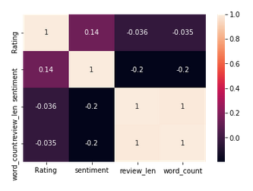
here come the

heatmap we will use it for the correlation which shows the correlation betwee the variables

these are histograms which shows the data datstribution of the data along with the ranges in the data, actually numrical variables and catrgoriacal

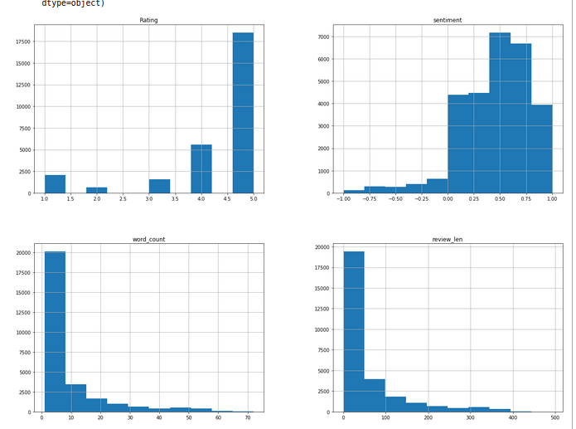
variables contains different plots which shoud be understood and to be used

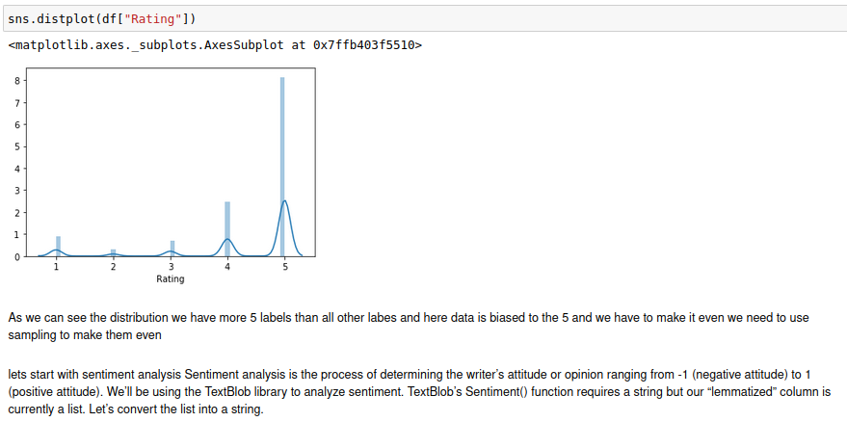
these plots are called distplots which shows us about the distribution is noramlized or not because most of the machine learning models deals with the nrmalized data with the help of these plots we can apply which plot should ue at what time

Outliers detection and removal one of the most important proces of the machine learning project here we have to find the outliers and we shoutld remove them before proceeding to the project, plots which bassically used for outlier detction are boxplot and scatterplot

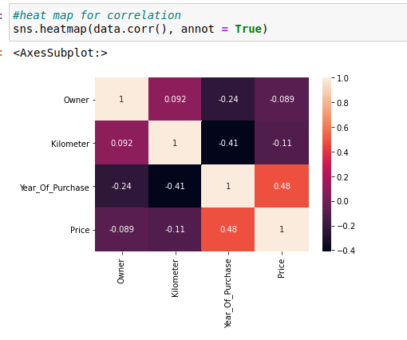
this is the correlation map for the data

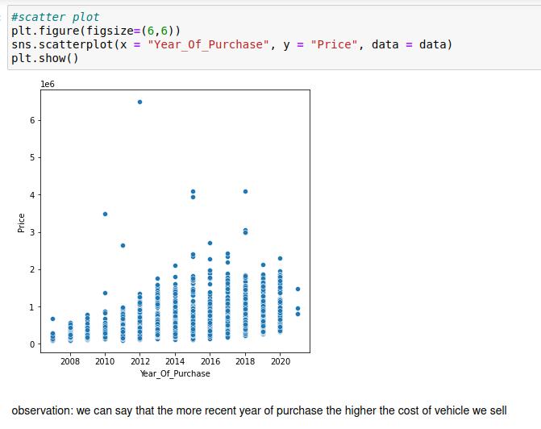

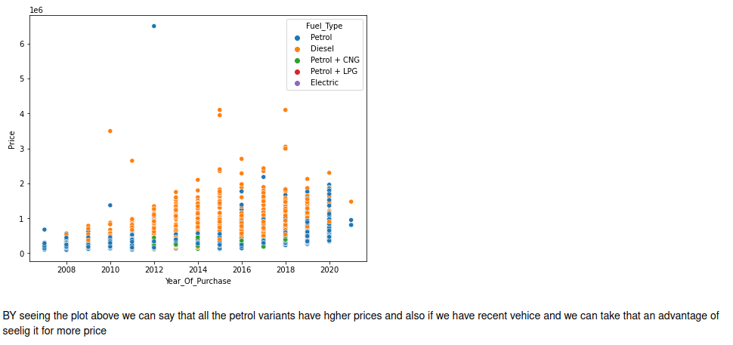

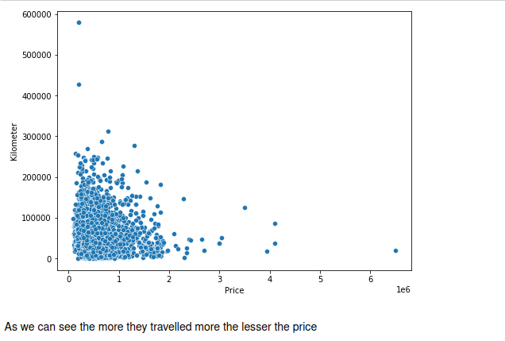
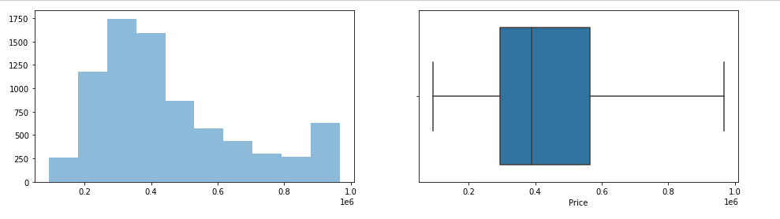

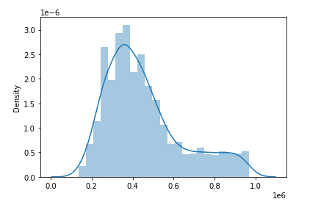

this is sentiment histogram here we are gathering all the sentiments of the data
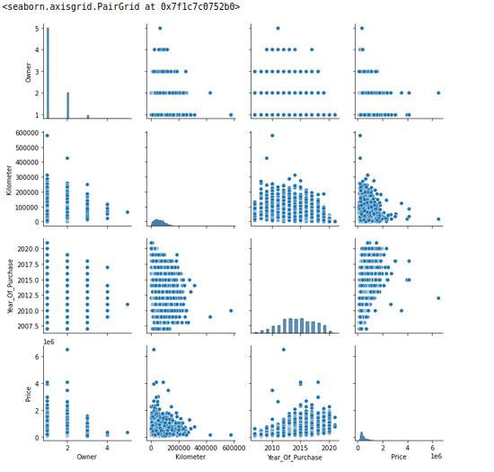
And atlast we have pairplot that shows relation between variables

- Interpretation of the Results
Two types of datasets are present with the problem statement one is training data with 81 dimensions nad 7000 records and another test dataset with 8 dimensions
By the problem solution we have to create a machine learning model which predicts the prices of te houses based on the data providedand
Then using the model we have to use it to preict the prices using the test dataset when i bserved the test set we dont have one problem with it most of the datasets have multiple categorical data that dont match with the train set so we need to concatinate the both trainig and testing datasets and later we can divide them
we have soma nul values also at first we have to replace the nul values and then we have to encode th categorical columns and then we have to divide the test and training data after that scale the data accordingly, we have to predict the prices here i am using linear regression along with the regularizations Lasso and ridge and i want to include ensemble techniques like random forest regressr and aaboost and then checking the metrics of the regression and
later appying the model on test set to find the predction price values

CONCLUSION
- Key Findings and Conclusions of the Study

The min key finding of the data is how we ahve to make encoded data do that we can feed to machine learning model , the way we amke the data encoded id the importnt thing in creating the machine learning model

- Learning Outcomes of the Study in respect of Data Science
From this project we can learn about many things like how to handle bigger data and how to handle the the nullvalues and how to check the sewness and the outliers along with handling them and also dividing the dataset checking the metrics of the dataset and many other thing, the main important thing is that we can learn how to adjuset the metrics of the model

- Limitations of this work and Scope for Future Work
there ais only one limitation and that is data i have nly some amount of the data actually the more data the better model

